2024
VCE
Specialist Mathematics
Year 12
Trial Examination 2



Kilbaha Education (Est. 1978) (ABN 47 065 111 373)  PO Box 3229  Cotham Vic 3101  Australia | PayID: 47065111373  Email: kilbaha@gmail.com  Tel: (03) 9018 5376  Web: https://kilbaha.com.au

All publications from Kilbaha Education are digital and are supplied to the purchasing school in both WORD and PDF formats with a school site licence to reproduce for students
in both print and electronic formats.
IMPORTANT COPYRIGHT NOTICE

- This material is copyright. Subject to statutory exception and to the provisions of the relevant collective licensing agreements, no reproduction of any part may take place without the written permission of Kilbaha Education.
- The contents of this work are copyrighted. Unauthorised copying of any part of this work is illegal and detrimental to the interests of the author.
- For authorised copying within Australia please check that your institution has a licence from http://copyright.com.au. This permits the copying of small parts of the material, in limited quantities, within the conditions set out in the licence.

Reproduction and communication for educational purposes The Australian Copyright Act 1968 (the Act) allows a maximum of one chapter or 10% of the pages of this work, to be reproduced and/or communicated by any educational institution for its educational purposes provided that educational institution (or the body that administers it) has given a remuneration notice to Copyright Agency Limited (CAL) under the Act.

For details of the CAL licence for educational institutions contact CAL,
Email: info@copyright.com.au

- All of these pages must be counted in Copyright Agency Limited (CAL) surveys

- This file must not be uploaded to the Internet.

These suggested answers have no official status.

While every care has been taken, no guarantee is given that these answers are free from error. Please contact us if you believe you have found an error.

CAUTION NEEDED!
All Web Links when created linked to appropriate Web Sites. Teachers and parents must always check links before using them with students to ensure that students are protected from unsuitable Web Content. Kilbaha Education is not responsible for links that have been changed in this document or links that have been redirected.

Kilbaha Education (Est. 1978) (ABN 47 065 111 373)  PO Box 3229  Cotham Vic 3101  Australia | PayID: 47065111373  Email: kilbaha@gmail.com  Tel: (03) 9018 5376  Web: https://kilbaha.com.au

Victorian Certificate of Education
2024

STUDENT NUMBER
Letter
Figures
Words

SPECIALIST MATHEMATICS
Trial Written Examination 2

Reading time: 15 minutes
Total writing time: 2 hours

QUESTION AND ANSWER BOOK

Structure of book
Section Number of Number of questions Number of
questions to be answered marks
A 20 20 20
B 6 6 60
Total 80

- Students are permitted to bring into the examination room: pens, pencils, highlighters, erasers, sharpeners, rulers, a protractor, set squares, aids for curve sketching, one bound reference, one approved technology ( calculator or software ) and, if desired, one scientific calculator. Calculator memory DOES NOT need to be cleared. For approved computer-based CAS, full functionality may be used.
- Students are NOT permitted to bring into the examination room: blank sheets of paper and/or correction fluid/tape.
Materials supplied
- Question and answer book of 31 pages.
- Detachable sheet of miscellaneous formulas at the end of this booklet.
- Answer sheet for multiple-choice questions.
Instructions
- Detach the formula sheet from the end of this book during reading time.
- Write your student number in the space provided above on this page.
  - Write your name and student number on your answer sheet for multiple-choice questions and sign your name in the space provided.
- All written responses must be in English.
- Place the answer sheet for multiple-choice questions inside the front cover of this book.

Students are NOT permitted to bring mobile phones and/or any other unauthorised electronic devices into the examination room.

SECTION A
Instructions for Section A

Answer all questions in pencil on the answer sheet provided for multiple-choice questions.
Choose the response that is correct for the question.
A correct answer scores 1 mark, an incorrect answer scores 0.
Marks will not be deducted for incorrect answers.
No mark will be given if more than one answer is completed for any question.
Take the acceleration due to gravity to have magnitude g m/s², where .

Question 1

Consider the following two statements
- If the heating is on, then the room will not be cold.
- If the room is cold, then the heating is not on.

Then

A. statement (2) is the negation of statement (1).
B. statement (2) is the converse of statement (1).
C. statement (2) is the contrapositive of statement (1).
D. statement (2) is the inverse of statement (1).
Question 2

Consider the function with the rule , where a and b are real non-zero constants.
Alan stated that the graph of the function has three straight line asymptotes if .

Ben stated that the graph of the function has two straight line asymptotes and a point of discontinuity if .
Colin stated that the graph crosses the x-axis at and crosses the y-axis at
and has a maximal domain of Then
A. Only Alan is correct.
B. Only Ben is correct.
C. Only Colin is correct.
D. All of Alan, Ben and Colin are correct.

Question 3

Which of the following statements concerning complex numbers is necessarily true?
A. If and then .
B. If and then .
C. If and then .
D. If and and then then and .
Question 4

Consider the two lines and .
Then
A. The two lines are parallel and do not intersect.
B. The two lines are the same line.
C. The two lines are not parallel and they intersect.
D. The two lines are not parallel and they do not intersect.
Question 5

To prove for using mathematical induction, in the inductive step it is
necessary to assume that and show that
A.
B.
C.
D.

Question 6

Let for , then

A.
B.
C.
D.

Question 7

Given and , the closest distance between the planes
and is
A.
B.
C. 1
D.

Question 8
A particle is travelling on a circle. If then
A. and the particle moves clockwise around the circle.
B. and the particle moves clockwise around the circle.
C. and the particle moves anticlockwise around the circle.
D. and the particle moves anticlockwise around the circle.

Question 9

The scalar resolute of in the direction , is p.
The scalar resolute of in the direction where p,n,m are all non-zero real numbers is
A.
B.
C.
D.

Question 10

If is the angle between the two non-zero vectors and , then which of the following is false?
A.
B.
C. If is parallel to , then and if is perpendicular to , then
D. is a unit vector perpendicular to both and

Question 11
If and where k is a non-zero real constant, then is equal to
A.
B.
C.
D.
Question 12
Let z be a complex number, in the Argand plane, represents

A. a straight line
B. a circle
C. an ellipse
D. an hyperbola

Question 13

Consider the function where .
Then which of the following is false?
A. If then graph of the function f has no turning points
and no points of inflexion.

B. If then graph of the function f has two turning points and two points of
inflexion.

C. If then graph of the function f has one turning point and two points of
inflexion.

D. If then graph of the function f has no turning points and no
points of inflexion.

Question 14

The number of penguins in an enclosure at a time t years, satisfies the equation
, which of the following is false?
A. The number of penguins satisfies the differential equation
B. The initial number of penguins was 10 and the number of penguins cannot exceed 100.

C.
D. The penguin growth rate is increasing most rapidly when
Question 15
When Euler’s method, with a step size of , is used to solve the differential equation
with , the value of is equal to

A.
B.
C.
D.
Question 16

The direction ( slope ) field for a certain differential equation is shown below.

The differential equation could be
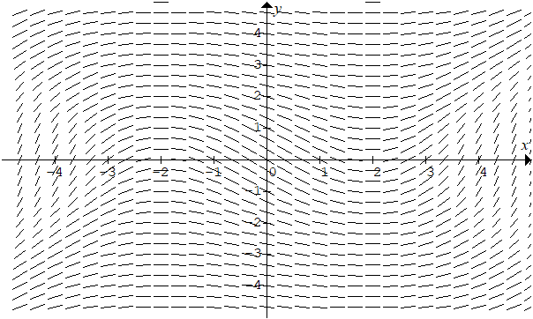

A.
B.
C.
D.

Question 17

A hot air balloon is accelerating upwards with an acceleration of . At a particular instant it is 100 metres above ground level and rising upwards with a speed of , a small stone falls from the balloon to the ground. Assuming air resistance is negligible, the time taken, for the stone to hit the ground in seconds, is closest to

A. 4.55
B. 4.68
C. 4.73
D. 5.00

Question 18

A 95% confidence interval for a population mean is given by .
The 99% confidence interval for the population mean is closest to

A.
B.
C.
D.

Question 19

The masses of packages of butter produced by a company are assumed to be normally distributed with a known mass of grams with a standard deviation of 6 grams. The containers of butter are labelled to contain 250 grams. Given there is a 20% probability that the mean mass of 25 randomly selected containers will be less than the labelled amount, then the value of is closest to

A. 255.05
B. 251.01
C. 248.99
D. 244.95

Question 20
A toy car moves in a straight line, its velocity at a time t seconds is given by and the velocity time graph is shown below.
Over the first seven seconds, which of the following is false?

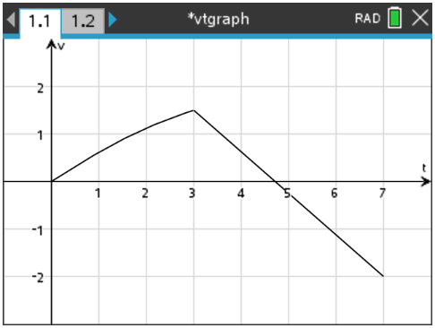

A. and
B. The toy car moves a total distance of metres.
C. The toy car has a displacement of metres.
D. The average speed of the toy car in is .

END OF SECTION A
SECTION B
Instructions for Section B

Answer all questions in the spaces provided.
Unless otherwise specified an exact answer is required to a question.
In questions where more than one mark is available, appropriate working must be shown.
Unless otherwise indicated, the diagrams in this book are not drawn to scale.
Take the acceleration due to gravity to have magnitude g m/s², where .

Question 1 (10 marks)
Let
a. State the equations of the asymptotes on the graph of .
1 mark
______________________________________________________________________________________________________________________________________________________________________________________________________________________________________________________________________________________________________________________________________________________________________________________________________________________________________________________

b. Find the coordinates of the turning points on the graph of .
1 mark
______________________________________________________________________________________________________________________________________________________________________________________________________________________________________________________________________________________________________________________________________________________________________________________________________________________________________________________

c. Sketch the graph of on the set of axes below. Label the asymptotes with their equations, and label the turning points and the point of inflexion with their coordinates, correct to two decimal places. Label the axial intercepts with the coordinates.
3 marks

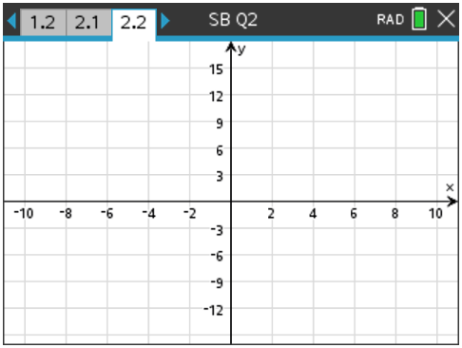

d. Consider now the graph of , where k is a real constant.
i. For what values of k will the graph of have a point of discontinuity.
1 mark
__________________________________________________________________________________________________________________________________________________
_________________________________________________________________________

ii. For what values of k will the graph of cross the horizontal asymptote.
1 mark
___________________________________________________________________________________________________________________________________________________________________________________________________________________________

iii. Complete the table below.
3 marks

values of k | the graph of has
 | two turning points
 | one turning point
 | no turning points
 | no points of inflection
 | one point of inflection

Question 2 (10 marks)

a. Let and be two circles in the complex plane.

i. Express both and in Cartesian form.
2 marks

____________________________________________________________________________________________________________________________________________________________________________________________________________________________________________________________________________________________________

ii. The non-zero point of intersection between and can be expressed as the complex number , find the values of a and b, where
1 mark

_____________________________________________________________________________________________________________________________________________________________________________________________________________________________________________________________________________________________________________________________________________________________________________

iii. A ray S, which passes through the complex number u and the centre of the circle
can be expressed as
Determine the real numbers d and p.
2 marks

______________________________________________________________________________________________________________________________________________________________________________________________________________________________________________________________________________________________________________________________________________________________________________________________________________________________________________________

b. Sketch the circles , and the ray S on the Argand diagram below.
2 marks

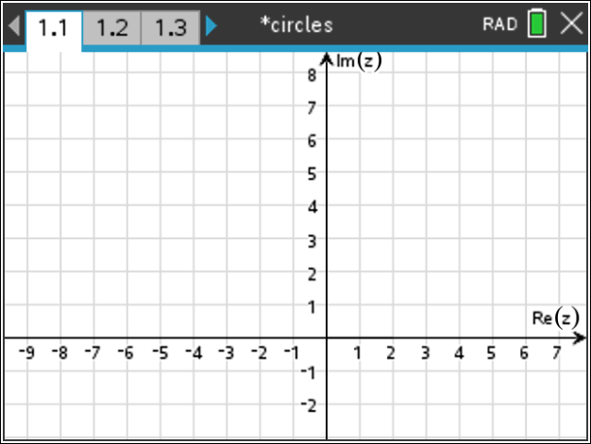

c. Determine and shade the area corresponding to
.
3 marks

_______________________________________________________________________________________________________________________________________________________________________________________________________________________________________________________________________________________________________________________________________________________________________________________________________________________________________________________________________________________________________________________________
Question 3 (10 marks)

The diagram shows a jug, with an open top, which is formed by rotating the curve for and about the y-axis, the jug has a height of H.
All lengths are measured in centimetres.
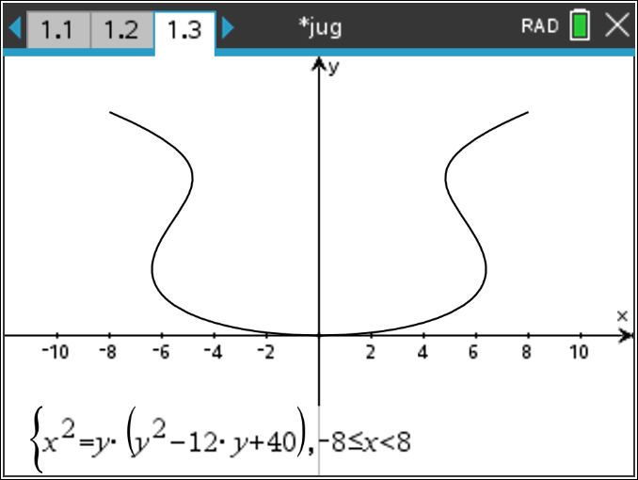
H
v
a. i. Find the value of H and determine the total capacity of the jug in when
filled to a height of H.
2 marks
_____________________________________________________________________________________________________________________________________________________________________________________________________________________________________________________________________________________________________________________________________________________________________________

ii. When the jug is filled with water to a height of h centimetres, where
show that the volume V in is given by
1 mark
_____________________________________________________________________________________________________________________________________________________________________________________________________________________________________________________________________________________________________________________________________________________________________________

b. i. The total curved surface area S cm² of the jug can be expressed as the definite
integral , state the values of b,p,q,r,s and t.
3 marks
________________________________________________________________________________________________________________________________________________________________________________________________________________________________________________________________________________________________________________________________________________________________________________________________________________________________________________________________________________________________________________________________________________________________________________________________________

ii. Determine the total curved surface area of the jug, in cm² giving your answer correct to two decimal places.
1 mark
______________________________________________________________________________________________________________________________________________

c. Unfortunately the jug has a small hole in the base and the water leaks out at a rate equal to where h is the height of the remaining water in the jug. When filled the jug takes two minutes to empty, determine the value of the constant k.
3 marks
________________________________________________________________________________________________________________________________________________________________________________________________________________________________________________________________________________________________________________________________________________________________________________________________________________________________________________________________________________________________________________________________________________________________________________________________________
Question 4 (9 marks)

a. A particle P moves such that its position vector in metres after a time t seconds, is given by where Another particle Q initially at the point moves at some later time, and travels towards the point , such that its speed is double the speed of particle P. Given that the two particles collide, determine the time between the release of the two particles, and the point at which they collide.
Assume all positions are given in metres.

5 marks
________________________________________________________________________________________________________________________________________________________________________________________________________________________________________________________________________________________________________________________________________________________________________________________________________________________________________________________________________________________________________________________________________________________________________________________________________________________________________________________________________________________________________________________________________________________________________________________________________________________________________________________________________________________________________________________________________________________________________________________________________________________________________________________________________________________________________________________________________________________________________________________________________________

b. Let and
where c and d are positive real numbers and .
Prove that
4 marks
__________________________________________________________________________________________________________________________________________________________________________________________________________________________________________________________________________________________________________________________________________________________________________________________________________________________________________________________________________________________________________________________________________________________________________________________________________________________________________________________________________________________________________________________________________________________________________________________________________________________________________________________________________________________________________________________________________________________________________________________________________________________________________________________________________________________________________________________________________________________________________________________________________________________________________________________________________________________________________________________________________________________________

Question 5 (11 marks)

a. Given the point and the plane , find the coordinates of the point on the plane which is closest to the point A, and hence find the shortest distance between the point and the plane.
3 marks
______________________________________________________________________________________________________________________________________________________________________________________________________________________________________________________________________________________________________________________________________________________________________________________________________________________________________________________
b. Given the point and the line ,
find the coordinates of the point on the line which are closest to the point B, and hence find the shortest distance between the point and the line.
4 marks
_________________________________________________________________________________________________________________________________________________________________________________________________________________________________________________________________________________________________________________________________________________________________________________________________________________________________________________________________________________________________________________________________________________________________________________________________________________________________________________________________________________
___________________________________________________________________________________________________________________________________________________________________________________________________________________________

c. Given the line , and the plane .
Show that the line and the plane do not intersect and hence find the shortest distance between the line and the plane. Explain your results.
2 marks
________________________________________________________________________________________________________________________________________________________________________________________________________________________________________________________________________________________________________________________________________________________________________________________________________________________________________________________________________________________________________________________________________________________________________________________________________
d. Consider now the different line and the plane .
Determine the values of b and d for which this line and this plane intersect in
i. a unique point. ii. an infinite number of points.
2 marks
_________________________________________________________________________________________________________________________________________________________________________________________________________________________________________________________________________________________________________________________________________________________________________________________________________________________________________________________________________________________________________________________________________________________________________________________________________________________________________________________________________________

Question 6 (10 marks)

a. A watermelon is in the shape of an ellipsoid, and has a total length of 40 centimetres and
a total height of 20 centimetres.
.
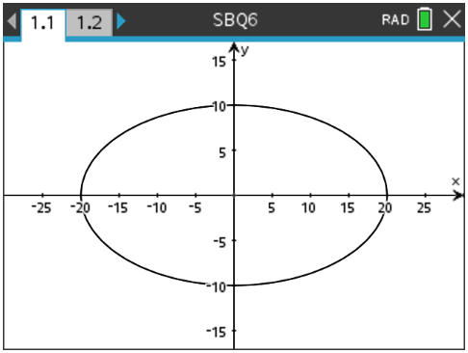
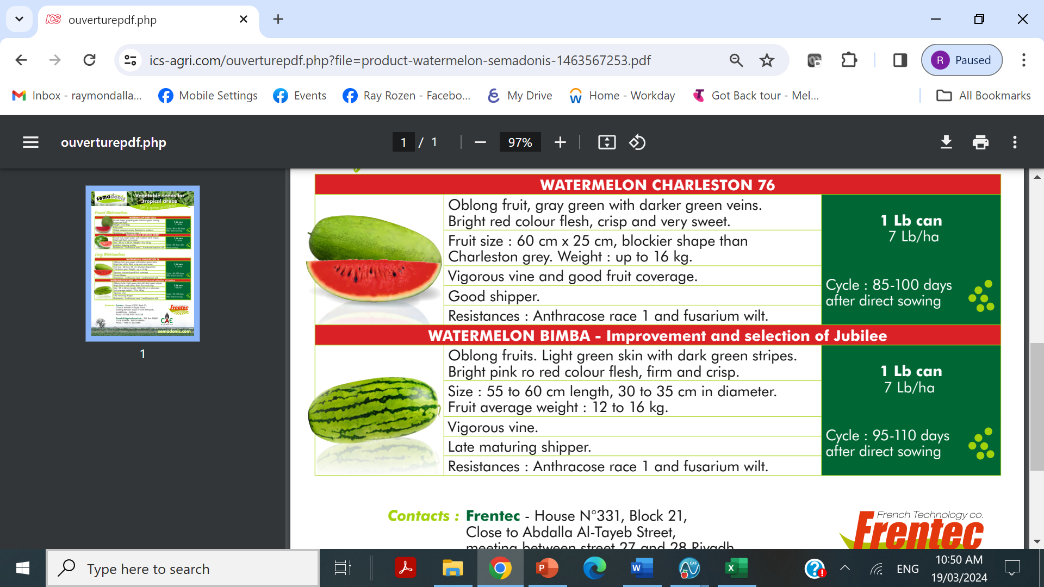

i. Determine the total surface area of the watermelon, giving your answer in square centimeters correct to two decimal places.
1 mark

_______________________________________________________________________________________________________________________________________________________________________________________________________________________________________________________________________________________________________________________________________________________________________________________

ii. Determine the volume of the watermelon, giving your answer in cubic centimetres.

1 mark
_____________________________________________________________________________________________________________________________________________________________________________________________________________________________________________________________________________________________________________________________________________________________________________________________________________________________________________________________________________________________________________________________________________

The weights of watermelons grown on an orchard are normally distributed with a mean mass of 3
kilograms with a standard deviation of 400 grams. The orchard also grows cantaloupes, the masses of
the cantaloupes are normally distributed with a mean mass of 1.5 kilograms with a standard deviation
of 200 grams.
b. Find the probability the total mass of three independent watermelons and two independent cantaloupes have a mass exceeding 11 kilograms. Give your answer correct to four decimal places.
2 marks
_______________________________________________________________________________________________________________________________________________________________________________________________________________________________________________________________________________________________________________________________________________________________________________________________________________________________________________________________________________________________________________________________
c. A random sample of n cantaloupes was calculated and a 95% confidence interval was
found to be kilograms. Determine the value of n.
1 mark
_____________________________________________________________________________________________________________________________________________________________________________________________________________________________________________________________________________________________________________________________________________________________________________

The farmer who grows the watermelons on the orchard, suspects that his watermelons have not fully
grown and it is desired to have the mean masses of the watermelons to be 3 kilograms. The farmer
tests 36 watermelons and finds their mean mass to be 2.9 kilograms.

d. Write down the null and alternative hypothesis for the test.
1 mark
__________________________________________________________________________________________________________________________________________________

The farmer decides to apply a one-tailed test at the 5% level of significance and assumes that
the weights of watermelons grown on the farm are normally distributed with a mean mass of 3 kilograms with a known standard deviation of 400 grams

e. Find the p value for the test correct to four decimal places and hence determine a conclusion about the alternative hypothesis from this test.
2 marks
___________________________________________________________________________________________________________________________________________________________________________________________________________________________
f. What is the critical sample mean in this test for the masses of the random sample of 36 watermelons, for the null hypothesis not to be rejected. Give your answer correct to four decimal places.
1 mark
___________________________________________________________________________________________________________________________________________________________________________________________________________________________

g. Suppose that the true mean mass of the watermelons is 2.8 kg and the standard deviation is still 400 grams. What is the probability of making a type II error in this statistical test.
Give your answer as a percentage correct to one decimal place.
1 mark
_____________________________________________________________________________________________________________________________________________________________________________________________________________________________________________________________________________________________________________________________________________________________________________

END OF SECTION B

End of question and answer book for the

2024 Kilbaha VCE Specialist Mathematics Trial Examination 2

Kilbaha Education (Est. 1978) (ABN 47 065 111 373)  PO Box 3229  Cotham Vic 3101  Australia | PayID: 47065111373  Email: kilbaha@gmail.com  Tel: (03) 9018 5376  Web: https://kilbaha.com.au

SPECIALIST MATHEMATICS

Written examination 2

FORMULA SHEET

Directions to students

Detach this formula sheet during reading time.

This formula sheet is provided for your reference.

Specialist Mathematics formulas

Mensuration

area of a  circle segment |  | volume of  a sphere
volume of  a cylinder |  | area of  a triangle
volume of  a cone |  | sine rule
volume of  a pyramid |  | cosine rule

Algebra, number and structure ( complex numbers )

de Moivre’s
theorem

Circular (trigonometric) functions

Data analysis, probability and statistics

for independent
random variables
for independent
identically distributed variables
approximate confidence
interval for
distribution of sample  mean | mean
 | variance

Vectors in two and three dimensions

for  and | vector scalar product
 | vector cross product
vector equation of a line
parametric equation of line
vector equation of a plane
parametric equation of a plane
Cartesian equation of a plane
Calculus

Calculus- continued

product rule
quotient rule
chain rule
integration by parts
Euler’s method | then and
arc length parametric
surface area Cartesian
about the x-axis

surface area Cartesian
about the y-axis

surface area parametric
about the x-axis

surface area parametric
about the y-axis

Kinematics

acceleration
constant acceleration
formulas

END OF FORMULA SHEET

ANSWER SHEET

STUDENT NUMBER
Letter
Figures
Words

SIGNATURE ______________________________________

SECTION A

1 |  | A |  | B |  | C |  | D
2 |  | A |  | B |  | C |  | D
3 |  | A |  | B |  | C |  | D
4 |  | A |  | B |  | C |  | D
5 |  | A |  | B |  | C |  | D
6 |  | A |  | B |  | C |  | D
7 |  | A |  | B |  | C |  | D
8 |  | A |  | B |  | C |  | D
9 |  | A |  | B |  | C |  | D
10 |  | A |  | B |  | C |  | D
11 |  | A |  | B |  | C |  | D
12 |  | A |  | B |  | C |  | D
13 |  | A |  | B |  | C |  | D
14 |  | A |  | B |  | C |  | D
15 |  | A |  | B |  | C |  | D
16 |  | A |  | B |  | C |  | D
17 |  | A |  | B |  | C |  | D
18 |  | A |  | B |  | C |  | D
19 |  | A |  | B |  | C |  | D
20 |  | A |  | B |  | C |  | D

Kilbaha Education (Est. 1978) (ABN 47 065 111 373)  PO Box 3229  Cotham Vic 3101  Australia | PayID: 47065111373  Email: kilbaha@gmail.com  Tel: (03) 9018 5376  Web: https://kilbaha.com.au

